WEB APPLICATIONS DEVELOPMENT
The Mini Project
“Website for Tourism”

L.I.L.H.ALWIS
S92065319

Contents

- Cover page
- Problems
- Solutions
- Site Map
- Web technologies
- Results
- Conclusion
Problems

While completing the project I had to face several problems on Finding content, building the structure and some coding difficulties.

- Finding content
  - It was challenging to find content to the website because there are so many details but I had to choose the write once, It was bit time consuming.

- Building the structure
  - The second problem was arranging the gathered details in a order to make the structure.

- coding difficulties
  - next problem was beautifying the web site using codes.

Solutions

- Found government web sites and gathered some details from there.
- Looked in to sample web sites and got an idea to make my Own.
- Referred some videos and pdf about Markup Languages.

Site Map

Home
To Do List
About Us
Contact Us
Information

Plan Your Holiday in Sri-Lanka
First Name
GEOGRAPHY

HISTROY
Last Name

Province
CULTURE

Subject
PEOPLE

PROVINCE

Web technologies
- HTML – For designing the structure of the web page.
- CSS- For Styling the Content Of the Web page.
- Vue JS – To build the TODO list.
- Java script-To Develop Navigation Bar & Search Bar.
Results
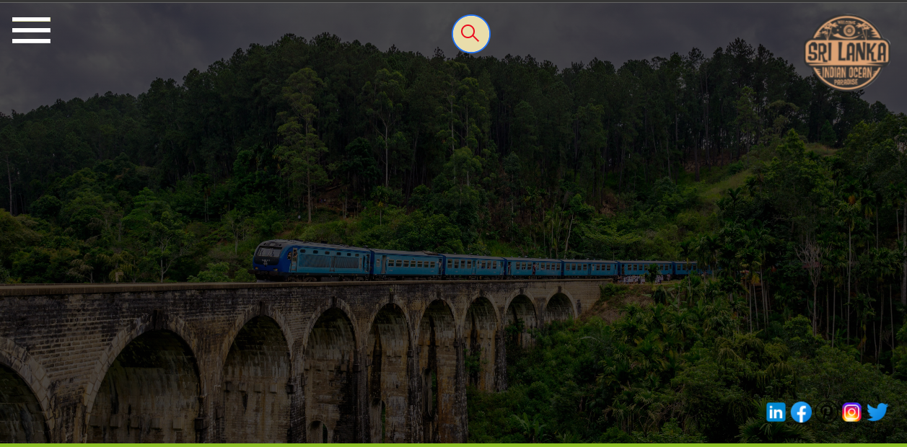
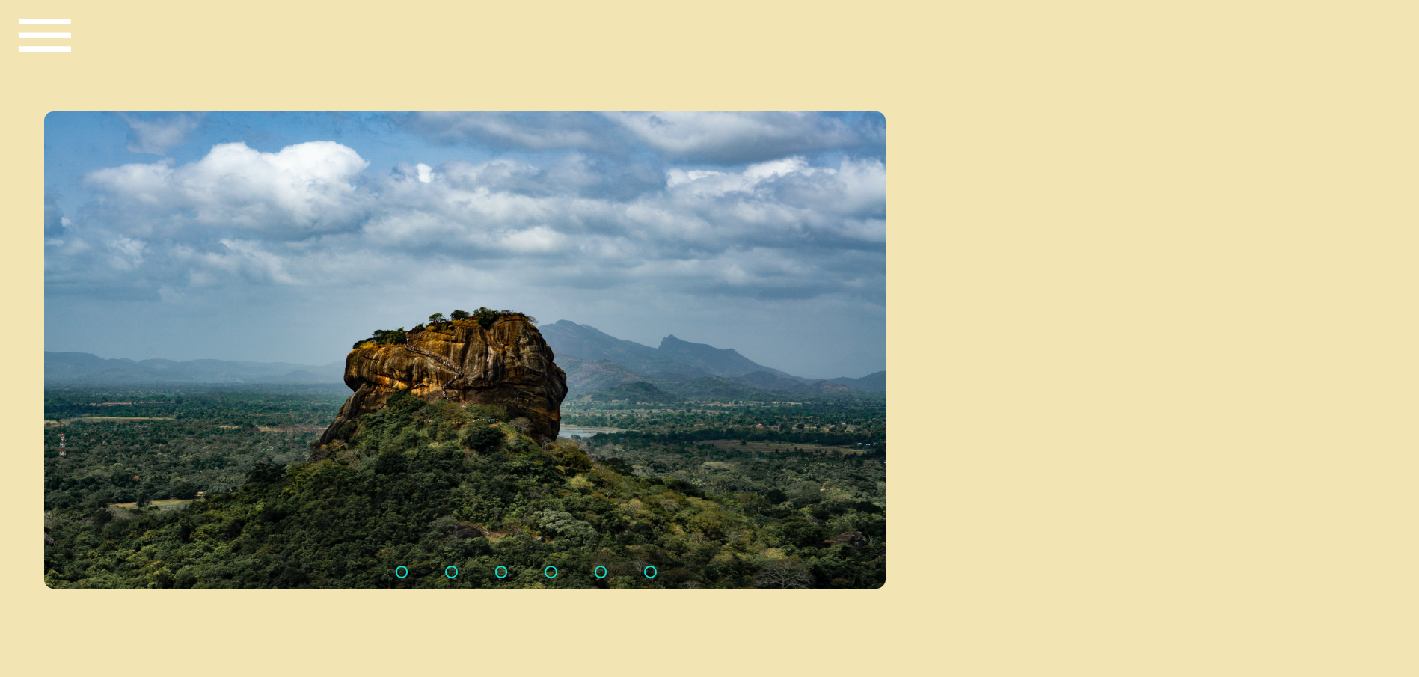
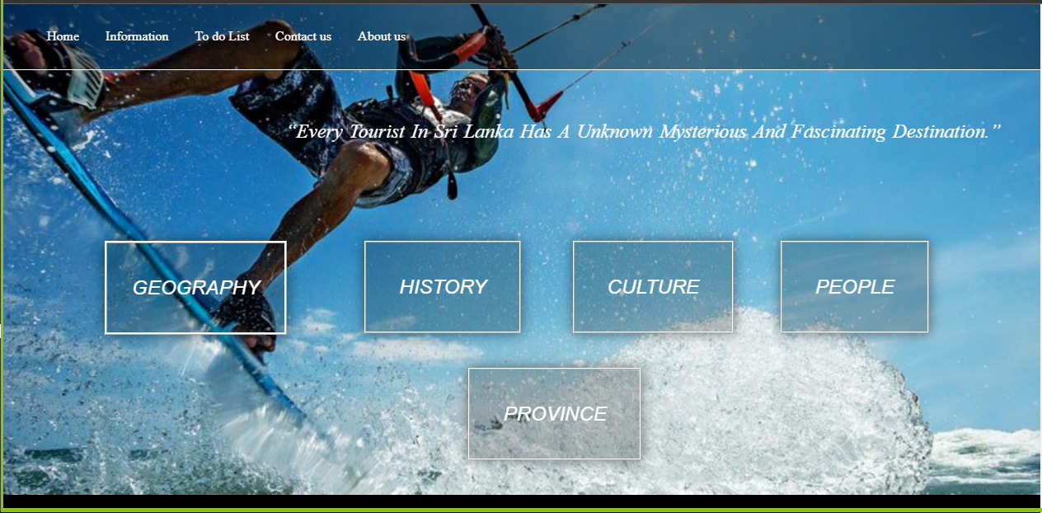
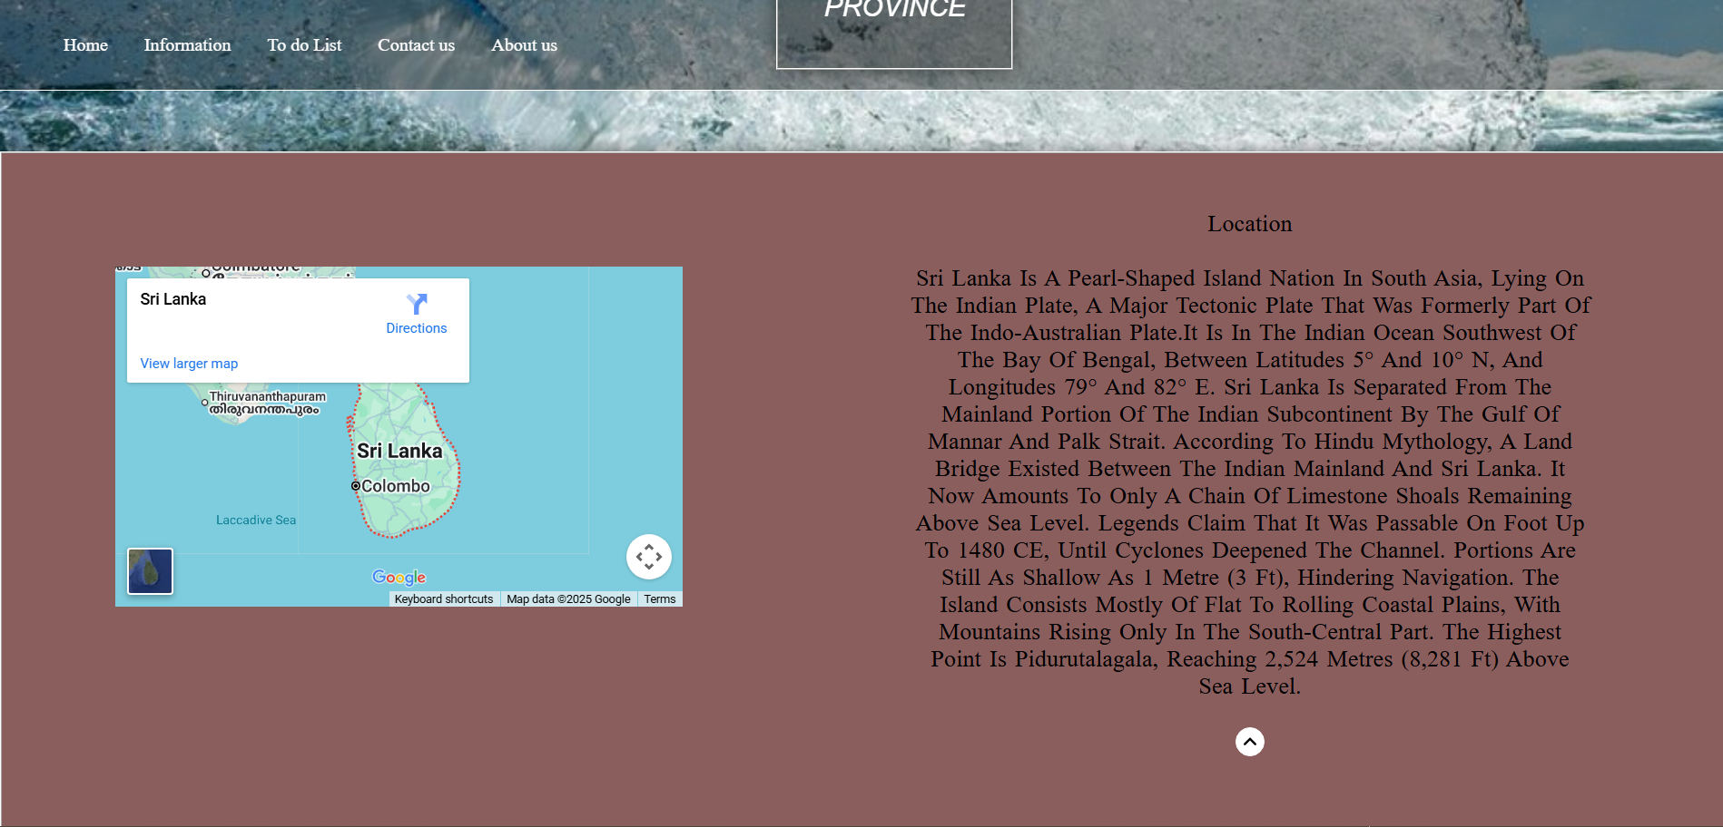
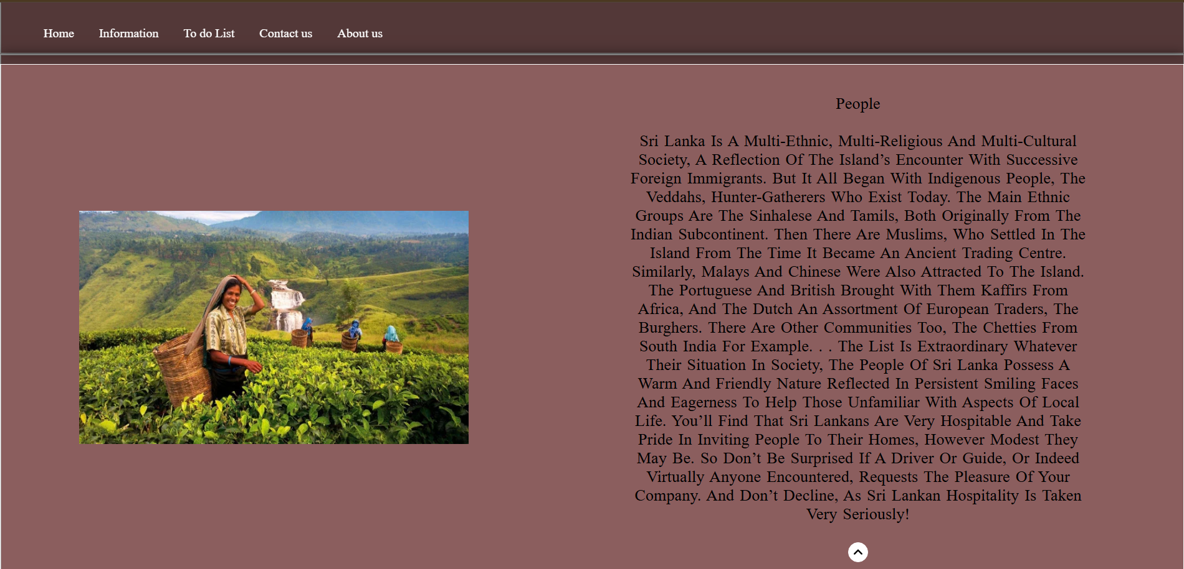
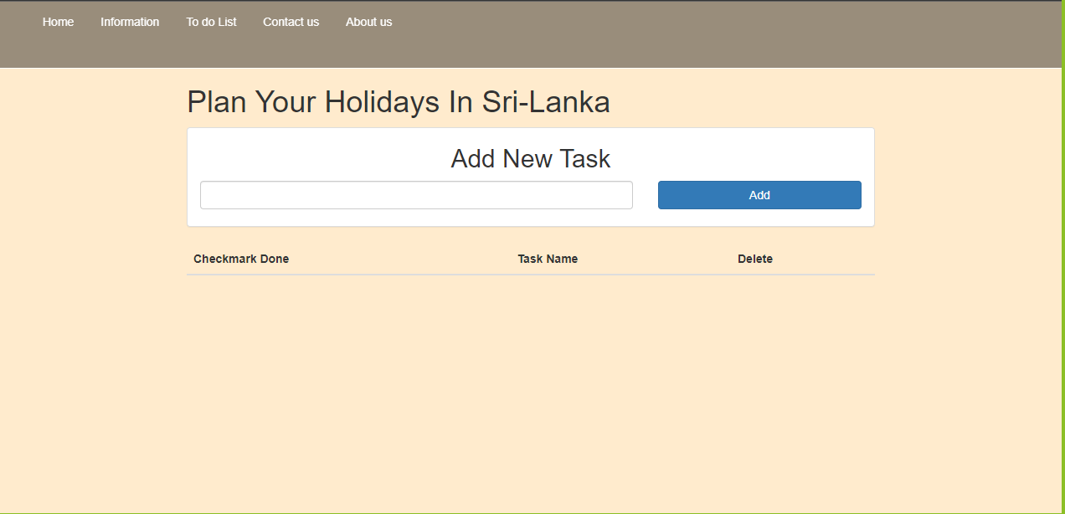
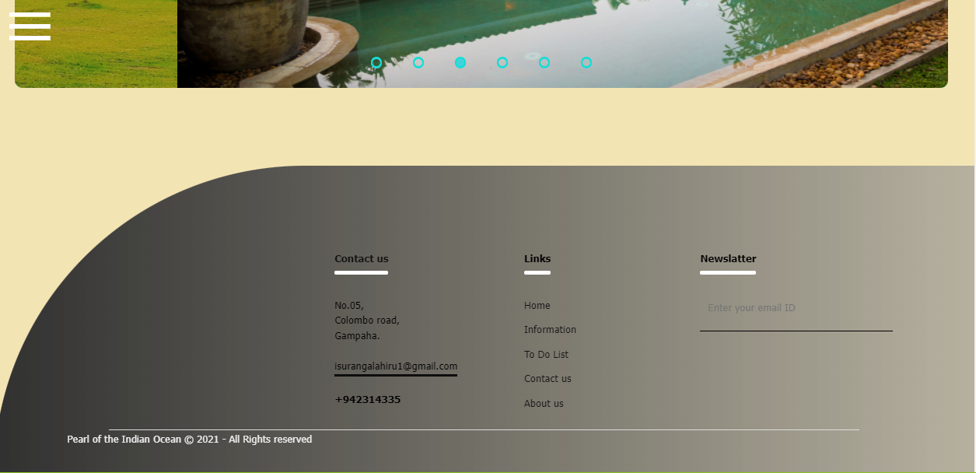
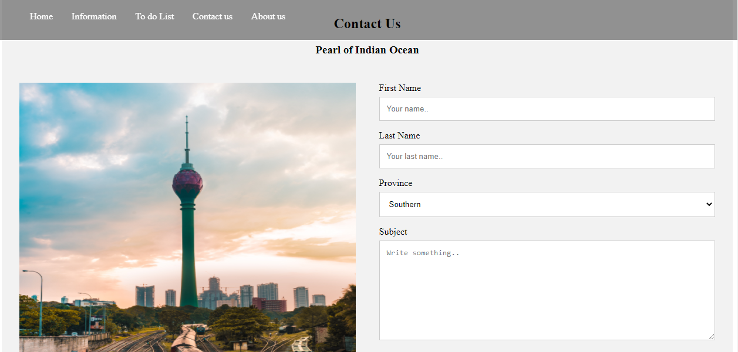


Conclusion

- When developing the website the most important thing is arranging the content and the structure. After that following the plan will get the work done.
- in this mini-project, I'm able to know about my talent in web development.
- it’s helped to improve my knowledge.
- I have learned many things via this project.

